Doplňovačka 1 – barový inventář

Jméno a příjmení:………………………………………………………..Třída………………Datum…………………..
Hodnocení…………………………………………………………………….

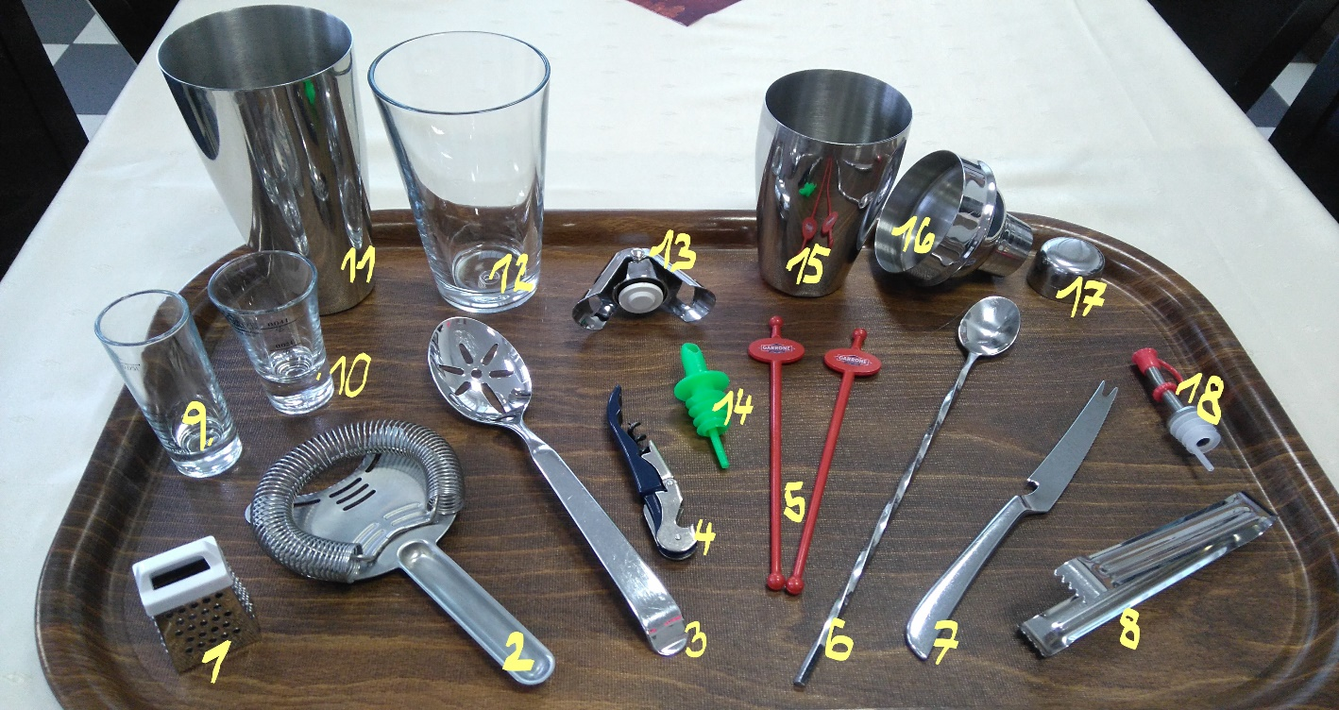

1/ __________________________________ 10/ __________________________________
2/ __________________________________ 11/ __________________________________

3/ __________________________________ 12/ __________________________________
4/ __________________________________ 13/ __________________________________
5/ __________________________________ 14/ __________________________________
6/ __________________________________ 15/ __________________________________
7/ __________________________________ 16/ __________________________________
8/ __________________________________ 17/ __________________________________
9/ __________________________________ 18/ __________________________________

